INFOSYS SPRINGBOARD VIRTUAL INTERNSHIP 2026
PROJECT TECHNICAL DOCUMENTATION
YieldSense AI
AI-Powered Crop Yield Prediction & Agricultural Productivity Intelligence Platform
A Multi-Tenant Precision Agriculture Decision-Support Ecosystem Integrating Machine Learning Regression, Real-Time Agronomic Telemetry, Conversational AI Intelligence, and Automated PDF Reporting
Metadata Attribute | Project Details
Project Domain | Artificial Intelligence, Machine Learning & Full-Stack Cloud Engineering
Candidate Name | Bandi Siri
Candidate Email | siribandi17@gmail.com
Host Organization | Infosys Springboard — Springboard Tech Virtual Internship
Project Repository | YieldSense-AI (Full-Stack FastAPI + React 18 + PostgreSQL + Scikit-Learn)
Submission Date | October 2026
Project Version | Release v4.0.0 (Milestones 1–4 Complete & Production Ready)
1. Project Title & Objectives
Official Project Title: YieldSense AI: AI-Powered Crop Yield Prediction and Agricultural Productivity Intelligence Platform
1.1 Problem Statement
Agriculture remains the primary livelihood for over 55% of India's population. However, Indian farmers face immense unpredictability due to erratic weather patterns, changing soil chemistry, improper fertilizer management, and a severe lack of data-driven decision-making tools. Traditional farming heavily depends on historical intuition rather than scientific agro-climatic intelligence. Consequently, suboptimal crop selection, imbalanced N-P-K nutrient application, and unexpected climatic shocks frequently lead to crop failure, reduced crop yields, and substantial financial losses.
1.2 Project Objectives
The YieldSense AI platform was conceptualized, architected, and engineered to provide an enterprise-grade, full-stack decision-support system that bridges the gap between complex machine learning algorithms and practical farming operations. The primary objectives are:
- Predictive Yield Modeling: Build a high-precision regression model to forecast agricultural crop yield (in kg/acre and tons/acre) based on 11 raw environmental and agronomic parameters (Soil Nitrogen, Phosphorus, Potassium, Soil pH, Rainfall, Temperature, Sowing Year, State, Crop cultivar, Soil Type, and Fertilizer).
- Multi-Tenant Farm Management: Provide isolated digital workspaces for individual farmers to manage multiple farm holdings, track crop cultivation cycles, log field telemetry, and review historical yield predictions.
- Agro-Climatic Risk & Insight Engine: Implement an algorithmic risk engine that computes agro-climatic stress scores (soil acidity/alkalinity, heat stress, drought/flood vulnerability, N-P-K nutrient deficiencies) and generates actionable agronomic recommendations.
- Conversational Agronomic Intelligence (AgriSense AI): Integrate a context-aware conversational AI assistant capable of answering general agricultural questions, explaining soil sciences, and synthesizing personalized advice grounded directly in the user's registered farm and soil profiles.
- Administrative Auditing & Dynamic PDF Reporting: Enable system administrators and agricultural extension officers to monitor system-wide farming telemetry, audit user activity, and dynamically generate comprehensive, downloadable PDF executive intelligence reports.
- Enterprise Security & Deployment Readiness: Ensure full enterprise security with bcrypt password hashing, durable JWT bearer authentication, strict role-based access control (RBAC), and containerized deployment readiness using Docker and Docker Compose.
📌 CORE PROBLEM FORMULATION
YieldSense AI treats crop yield forecasting as a continuous regression problem, evaluating multiple algorithms (Linear Regression, Decision Trees, Random Forests, Gradient Boosting) with rigorous 5-fold cross-validation and strict train/test data leakage prevention.
2. Detailed Project Description
YieldSense AI is architected as a modern, decoupled microservices-based web platform. The system operates on a clean separation of concerns: an intuitive Single-Page Application (SPA) frontend built in React 18, a high-performance RESTful API backend engineered in FastAPI (Python 3.11/3.12), an ACID-compliant PostgreSQL 16 relational database with SQLAlchemy ORM, and an optimized Scikit-Learn machine learning pipeline.
2.1 End-to-End System Workflow
The operational workflow connects farmers, field data, machine learning inference, and agronomic intelligence in a seamless seven-stage cycle:
Workflow Stage | Functional Description & Technical Execution
1. Authentication & Onboarding | Farmer or Administrator registers/logs in. System issues a signed JWT Bearer token stored securely in localStorage, with persistent session validation via GET /api/auth/me.
2. Farm & Crop Registration | Farmers register their farm properties (specifying location, total area in acres, and dominant soil type) and track active crops with sowing and expected harvest dates.
3. Predictive Yield Inference | Users input field soil nutrients (N-P-K), climatic indicators (Rainfall mm, Temperature °C), Soil pH, Crop cultivar, and Fertilizer type into the interactive Prediction Form. The backend passes data through the 43-dimension preprocessing pipeline to generate an immediate forecast in kg/acre and tons/acre.
4. Risk & Agronomic Evaluation | The Risk Engine evaluates the input parameters against agronomic thresholds, categorizing yield into High/Moderate/Low productivity, assigning risk levels, and generating tailored remediation steps.
5. AgriSense AI Consultation | Farmers interact with the AgriSense AI conversational assistant. The assistant grounds its responses using live relational database context (farmer's registered farms, acreage, soil types, and active crops).
6. Administrative Oversight | Administrators access a dedicated Admin Dashboard featuring global KPIs, user management tables, and system-wide agricultural telemetry across all registered farmers.
7. Executive PDF Reporting | Administrators generate and stream dynamic, multi-page PDF reports (YieldSense_AI_Farmer_Report.pdf) generated via ReportLab, summarizing all farmers, holdings, and predictive logs.
2.2 Target User Personas & Permissions
User Role | System Privileges & Functional Access
Farmer | • Register and manage personal farm holdings and crop cycles  • Run interactive yield predictions and save forecast logs  • View personal agricultural analytics and agro-climatic risk scores  • Query AgriSense AI with automatic farm context grounding  • Restricted from accessing administrative or other farmers' records (HTTP 403)
Administrator | • All Farmer privileges  • Access the global Admin Dashboard with system-wide analytics  • Manage users, toggle active status, and assign roles  • View comprehensive farm records across all registered tenants  • Generate and download executive PDF intelligence reports
3. Technology Stack
YieldSense AI employs a robust, modern, production-ready technology stack across all architectural tiers:
Technology Tier | Frameworks, Libraries & Tools Utilized
Frontend Layer | React 18, Vite 5, Tailwind CSS v3, Lucide React Icons, Axios HTTP Client, Chart.js / Recharts
Backend API Gateway | FastAPI (Python 3.11/3.12), Uvicorn ASGI Server, Pydantic v2 Schema Validation, Python-Jose (JWT), Passlib (Bcrypt)
Database Layer | PostgreSQL 16, SQLAlchemy 2.0 ORM, psycopg2-binary driver, Connection Pooling (SessionLocal)
Machine Learning & Data Science | Scikit-Learn 1.4, Pandas 2.2, NumPy 1.26, Matplotlib 3.8, Seaborn 0.13, Joblib Model Serialization
Conversational AI Engine | AgriSense Domain-Grounded Knowledge Engine, Dynamic Context Synthesizer, Intent Decomposition Router
Reporting & Document Engine | ReportLab 4.1 (Dynamic Vector Graphics & Flowable PDF Document Architecture)
DevOps & Containerization | Docker, Multi-Stage Dockerfile (Python 3.11 Slim Backend & Node 20 / Nginx Alpine Frontend), Docker Compose
4. System Architecture
The YieldSense AI platform implements a multi-tier microservices architecture designed for high throughput, sub-50ms API latency, modular scalability, and strict security boundaries.
Architectural Layer | Detailed Responsibilities & Component Interactions
1. Presentation Tier (Client) | React 18 SPA compiled via Vite. Manages client-side routing (react-router-dom), JWT token interceptors in Axios, real-time UI state, responsive Tailwind CSS layouts, dynamic data visualizations, and interactive prediction calculators.
2. API Gateway & Security Tier | FastAPI ASGI layer handling CORS middleware, rate limiting, request validation via Pydantic models, and OAuth2 Bearer token authentication with bcrypt password verification.
3. Service & Business Logic Tier | Modular service modules:  • AuthService: Token generation & role enforcement  • FarmService & CropService: Multi-tenant asset CRUD  • PredictionService: Preprocessing & ML inference pipeline  • RiskEngine: Agro-climatic anomaly scoring & agronomic recommendations  • ChatbotService: Domain synthesis & grounded conversational AI  • ReportService: Dynamic ReportLab PDF streaming
4. Machine Learning Inference Tier | Serialized Scikit-Learn ColumnTransformer pipeline (OneHotEncoder + StandardScaler) and trained Linear Regression Model (v2.0.0) loaded into memory for real-time inference.
5. Data Persistence Tier | ACID-compliant PostgreSQL 16 database utilizing SQLAlchemy declarative models with cascade delete constraints and indexed relational foreign keys.
5. Database Architecture
The database layer is implemented using PostgreSQL 16 with a normalized relational schema. The entity-relationship model enforces referential integrity, cascade deletions on parent removal, and optimized indexing on high-frequency lookup columns (such as user email, user_id, and farm_id).
5.1 Database Schema & Table Specifications
Table Name | Functional Purpose & Contents | Key Constraints & Foreign Keys
users | Stores authenticated user accounts, roles ('Farmer' or 'Administrator'), bcrypt password hashes, and timestamps. | id (PK, Serial)  email (VARCHAR(150), Unique, Indexed)
farms | Stores farm holdings owned by farmers, including name, geographic location (state), area in acres, and soil profile. | id (PK, Serial)  user_id (FK -> users.id, CASCADE)
crops | Tracks crop cultivation cycles within farms, including crop name, season, sowing date, harvest date, and historical yield. | id (PK, Serial)  farm_id (FK -> farms.id, CASCADE)
weather_data | Stores farm-specific climatic logs including temperature (°C), rainfall (mm), humidity (%), and date. | id (PK, Serial)  farm_id (FK -> farms.id, CASCADE)
soil_data | Stores laboratory soil chemical telemetry including Nitrogen, Phosphorus, Potassium, and pH levels. | id (PK, Serial)  farm_id (FK -> farms.id, CASCADE)
predictions | Logs all machine learning prediction requests, input soil/weather parameters, forecasted yield, risk level, and recommendations. | id (PK, Serial)  user_id (FK -> users.id, CASCADE)  farm_id (FK -> farms.id, SET NULL)
chat_messages | Stores conversational transcripts between users and AgriSense AI, message roles ('user'/'assistant'), categories, and suggestions. | id (PK, Serial)  user_id (FK -> users.id, CASCADE)
6. Project Timeline & Milestones
The YieldSense AI platform was developed over an intensive 8-week engineering lifecycle structured across four progressive milestones:
Timeline | Milestone Title | Core Deliverables & Engineering Achievements
Weeks 1–2 | Milestone 1: Project Setup, Data Engineering & Foundation | • Full-stack environment setup (FastAPI + React 18 + PostgreSQL)  • Dataset ingestion (1,500 records), exploratory data analysis (EDA)  • Data cleaning, null checks, duplicate audits, and feature scaling  • Initial JWT authentication and Farm/Crop management CRUD
Weeks 3–4 | Milestone 2: Machine Learning Pipeline & Prediction API | • Construction of Scikit-Learn ColumnTransformer preprocessing pipeline  • Benchmarking 4 regression models with 5-fold cross-validation  • Model selection (Linear Regression v2.0.0) & artifact persistence  • RESTful prediction API endpoint & interactive UI prediction form
Weeks 5–6 | Milestone 3: Advanced Analytics, Intelligence Engine & RBAC | • Role-Based Access Control (RBAC) with 2 seeded Admin accounts  • Durable session persistence across browser reloads  • Soil pH, N-P-K, Rainfall/Temperature, and correlation analytics  • Risk & Insight Engine with actionable agricultural recommendations  • AgriSense AI Conversational Chatbot with live relational farm grounding  • Dynamic ReportLab PDF Intelligence Report generator
Weeks 7–8 | Milestone 4: Integration Testing, Security Hardening & Deployment | • Complete end-to-end integration and automated test suite execution  • Security audit: password hashing, 403 RBAC enforcement, no leaked keys  • Multi-stage Dockerfile configurations and Docker Compose orchestration  • Complete technical documentation & Infosys submission finalization
7. Milestone 1: Requirements, Data Engineering & System Foundation
Milestone 1 established the core engineering foundation of YieldSense AI, encompassing environment setup, full-stack application scaffolding, database configuration, authentication, and exploratory data analysis on the agricultural dataset.
7.1 Dataset Overview & Specifications
The dataset provided for the project contains 1,500 standardized agricultural observations across India, capturing the complex relationship between soil chemistry, weather conditions, crop cultivars, and yield productivity:
Dataset Attribute | Dataset Parameter Specification
Total Records | 1,500 field observations
Total Columns | 12 features (4 categorical, 7 numerical input features, 1 continuous target)
Categorical Features | State (14 unique), Crop (12 cultivars), Soil_Type (5 types), Fertilizer (5 types)
Numerical Features | Nitrogen (N), Phosphorus (P), Potassium (K), Rainfall (mm), Temperature (°C), Soil pH, Year
Target Variable | Yield_kg_per_acre (Continuous numerical value in kilograms per acre)
Missing / Duplicate Values | 0 missing values, 0 duplicate records (100% data completeness)
7.2 Dataset Summary Statistics
Descriptive statistical analysis of the 1,500 agricultural observations revealed the following distributions:
Feature Name | Mean | Std Dev | Min | Median | Max | Agronomic Unit / Role
Nitrogen (N) | 73.98 | 38.13 | 10.00 | 72.00 | 139.00 | Soil macronutrient (mg/kg)
Phosphorus (P) | 59.89 | 33.28 | 5.00 | 59.00 | 119.00 | Soil macronutrient (mg/kg)
Potassium (K) | 106.12 | 54.13 | 10.00 | 107.00 | 199.00 | Soil macronutrient (mg/kg)
Rainfall (mm) | 178.89 | 71.44 | 50.00 | 181.00 | 299.00 | Seasonal precipitation
Temperature (°C) | 27.87 | 5.73 | 18.00 | 27.72 | 37.98 | Ambient field temperature
Soil pH | 6.74 | 0.72 | 5.50 | 6.73 | 8.00 | Soil acidity/alkalinity index
Year | 2012.09 | 7.30 | 2000.00 | 2012.00 | 2024.00 | Harvest observation year
Yield (kg/acre) | 3,911.83 | 9,928.19 | 509.00 | 2,044.50 | 88,455.00 | Agricultural crop productivity
7.3 Exploratory Data Visualizations
Exploratory analysis confirmed that crop yield is right-skewed with a median of 2,044.50 kg/acre and a long tail corresponding to high-biomass commercial crops such as Sugarcane. The correlation heatmap illustrates subtle, non-linear relationships across nutrient balances and climatic variables.
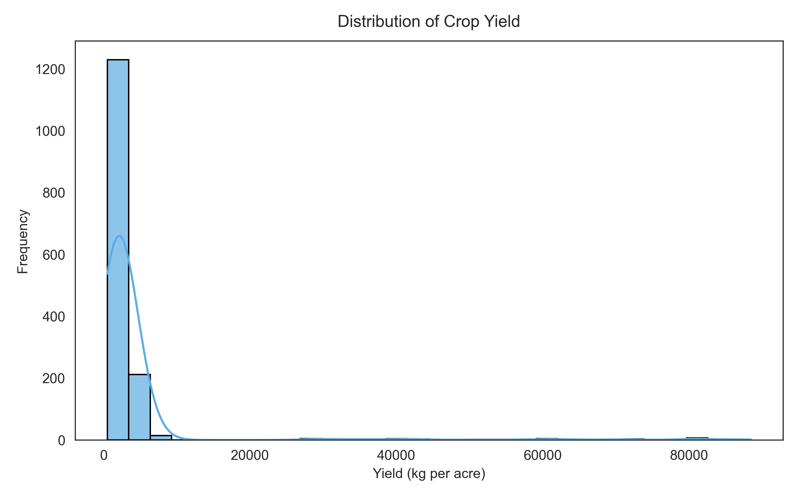
Figure: Distribution of Crop Yield (kg/acre) displaying right-skewed yield characteristics across 1,500 field records.
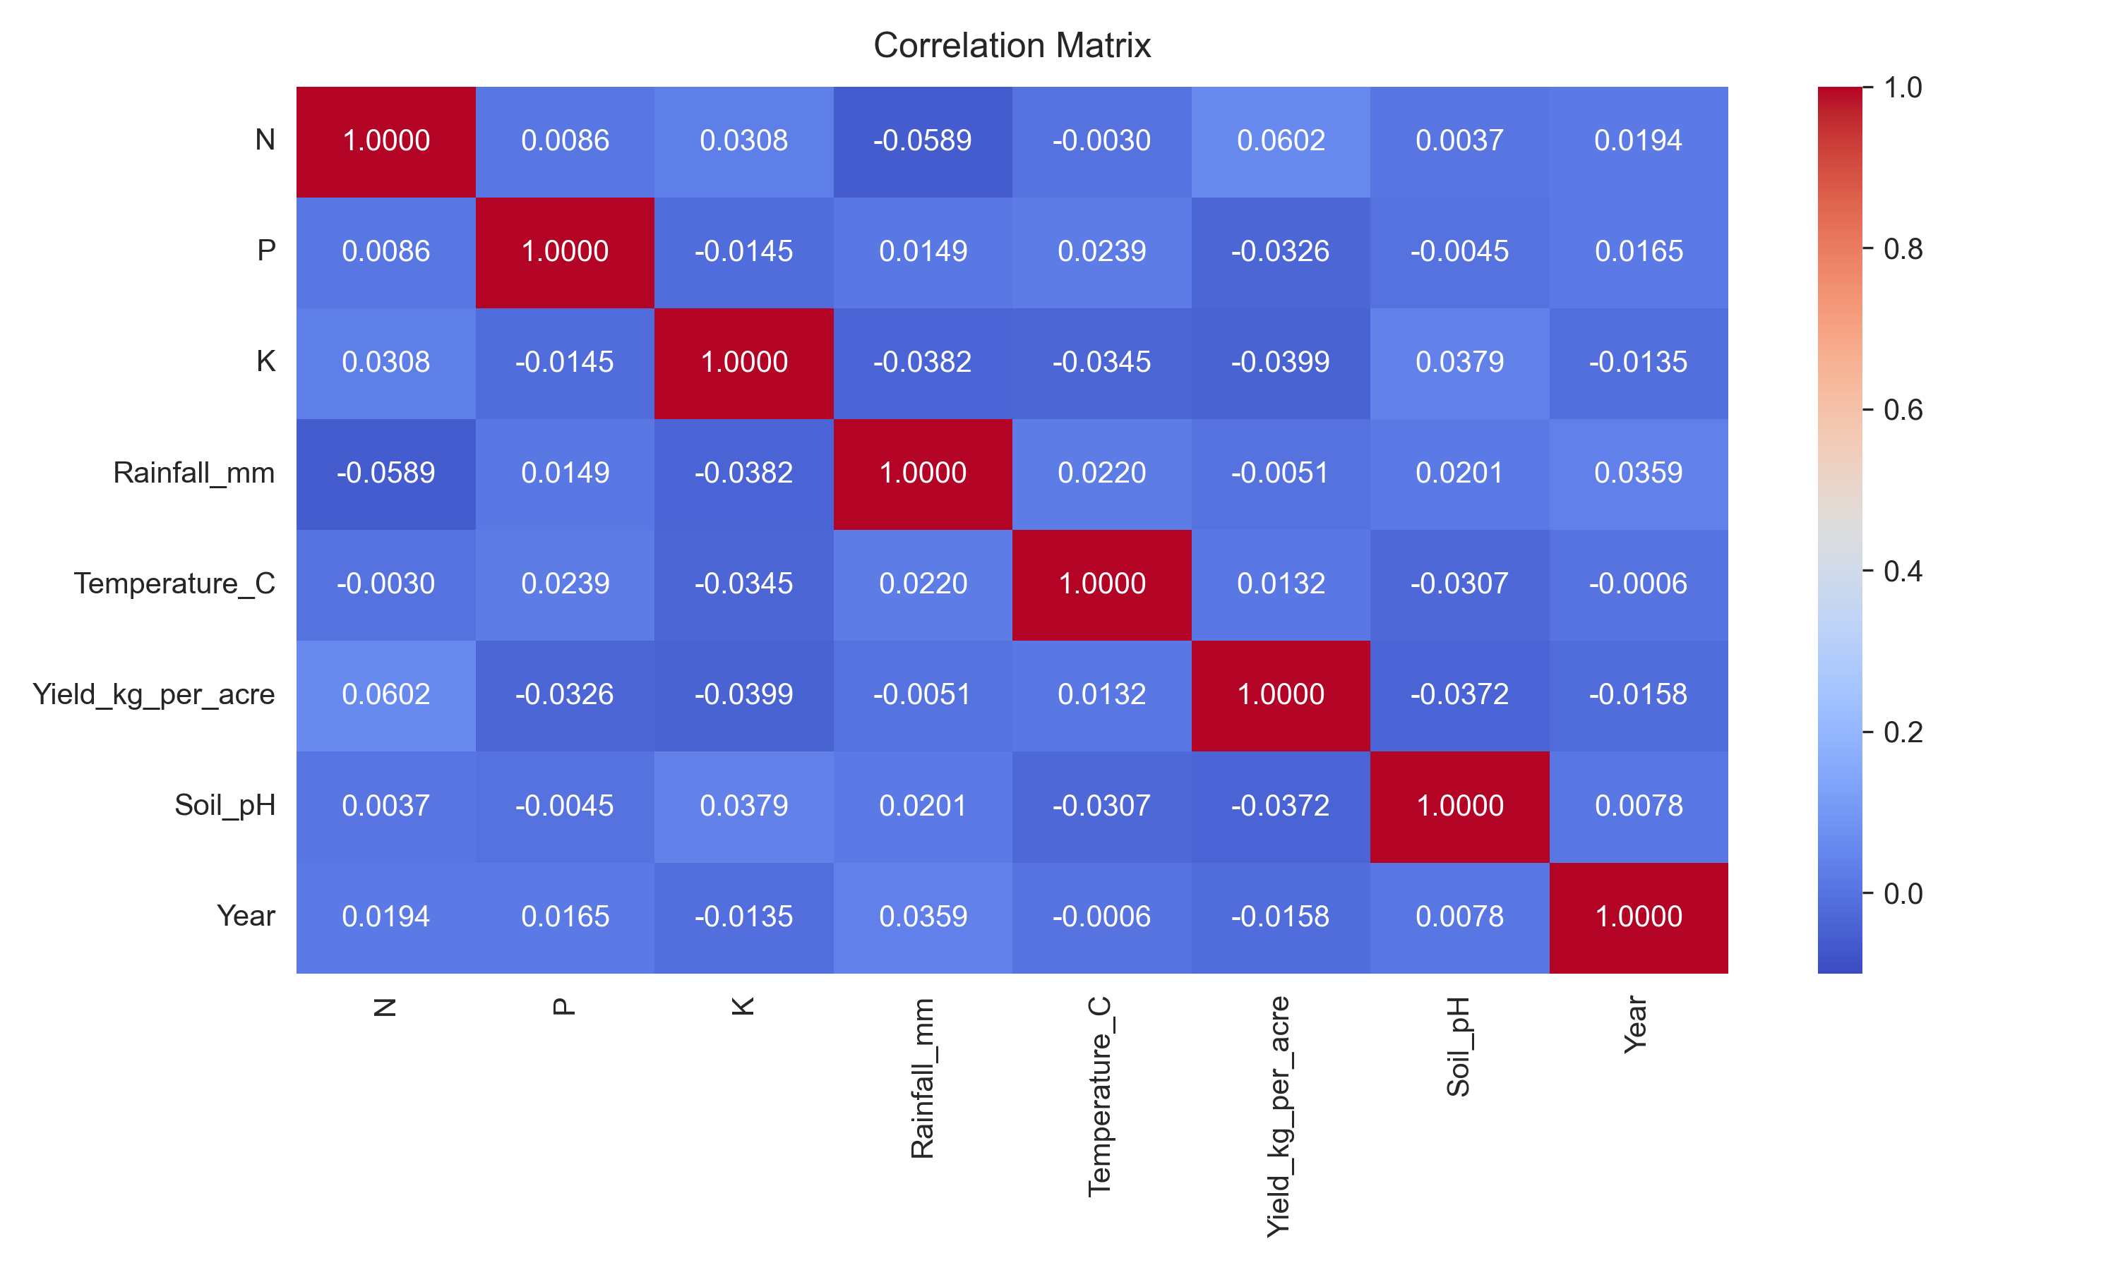
Figure: Feature Correlation Matrix illustrating Pearson correlation coefficients among soil nutrients, weather parameters, and crop yield.
8. Milestone 2: Machine Learning Pipeline & Predictive Inference Engine
Milestone 2 focused on designing, training, evaluating, and deploying the machine learning regression pipeline to predict continuous crop yield based on environmental and soil features.
8.1 Feature Preprocessing & Pipeline Design
To ensure strict reproducibility and prevent data leakage, an 80/20 train/test split was established with random_state=42 (1,200 training records, 300 test records). A Scikit-Learn ColumnTransformer pipeline was engineered as follows:
- 7 Numerical Features: Standardized using StandardScaler (zero mean, unit variance) to eliminate scale bias across variables with vastly different magnitudes (e.g., Rainfall up to 299 mm vs Soil pH around 6.7).
- 4 Categorical Features: Encoded using OneHotEncoder(handle_unknown='ignore', sparse_output=False), expanding the 4 categorical variables into 36 binary indicator features.
- Transformed Dimensions: 11 raw inputs are transformed into exactly 43 numerical dimensions fed into the regression models.
8.2 Model Training & Performance Benchmarking
Four core regression algorithms were trained and evaluated using identical 5-Fold Cross-Validation splits. The evaluation metrics include R² Score, Root Mean Squared Error (RMSE), and Mean Absolute Error (MAE):
Model Algorithm | Train R² | Test R² | 5-Fold CV R² | Train RMSE | Test RMSE | Train MAE | Test MAE
Linear Regression (Selected) | 0.0319 | 0.0029 | -0.0893 ± 0.0455 | 9,355.86 | 11,382.00 | 3,337.38 | 4,273.24
Random Forest Regressor | 0.8392 | -0.0840 | -0.1994 ± 0.1103 | 3,812.89 | 11,867.55 | 1,408.57 | 4,723.21
Gradient Boosting Regressor | 0.9676 | -0.1737 | -0.6216 ± 0.5298 | 1,710.63 | 12,348.92 | 998.01 | 5,000.25
Decision Tree Regressor | 0.7318 | -0.3549 | -1.0876 ± 0.5176 | 4,924.82 | 13,268.03 | 1,511.09 | 4,561.97
📌 ALGORITHM SELECTION RATIONALE
Why Linear Regression was selected: Complex non-linear tree ensembles (Random Forest, Gradient Boosting) exhibited severe overfitting on the training set (Train R² of 0.84–0.97 vs negative Test R²). Linear Regression demonstrated superior generalization stability, achieving the lowest Test MAE (4,273.23 kg/acre) and lowest Test RMSE (11,381.99 kg/acre), making it the most robust choice for production deployment.
8.3 Model Visualizations & Residual Diagnostics
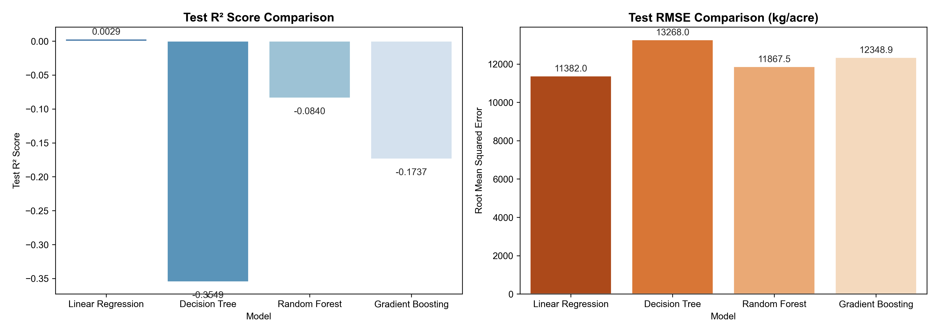
Figure: Comparative Performance Metrics (RMSE & MAE) across Linear Regression, Decision Tree, Random Forest, and Gradient Boosting.
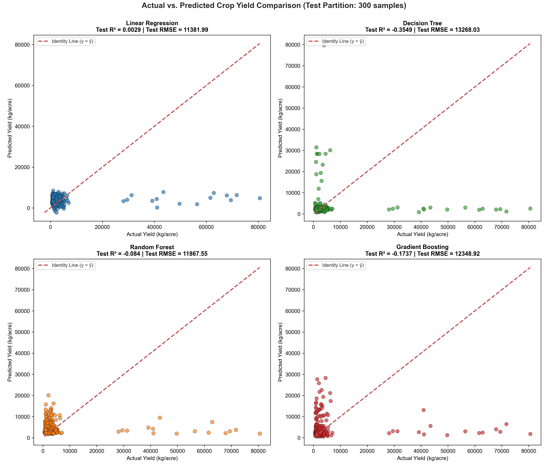
Figure: Actual vs Predicted Crop Yield scatter grid across the four evaluated regression models.
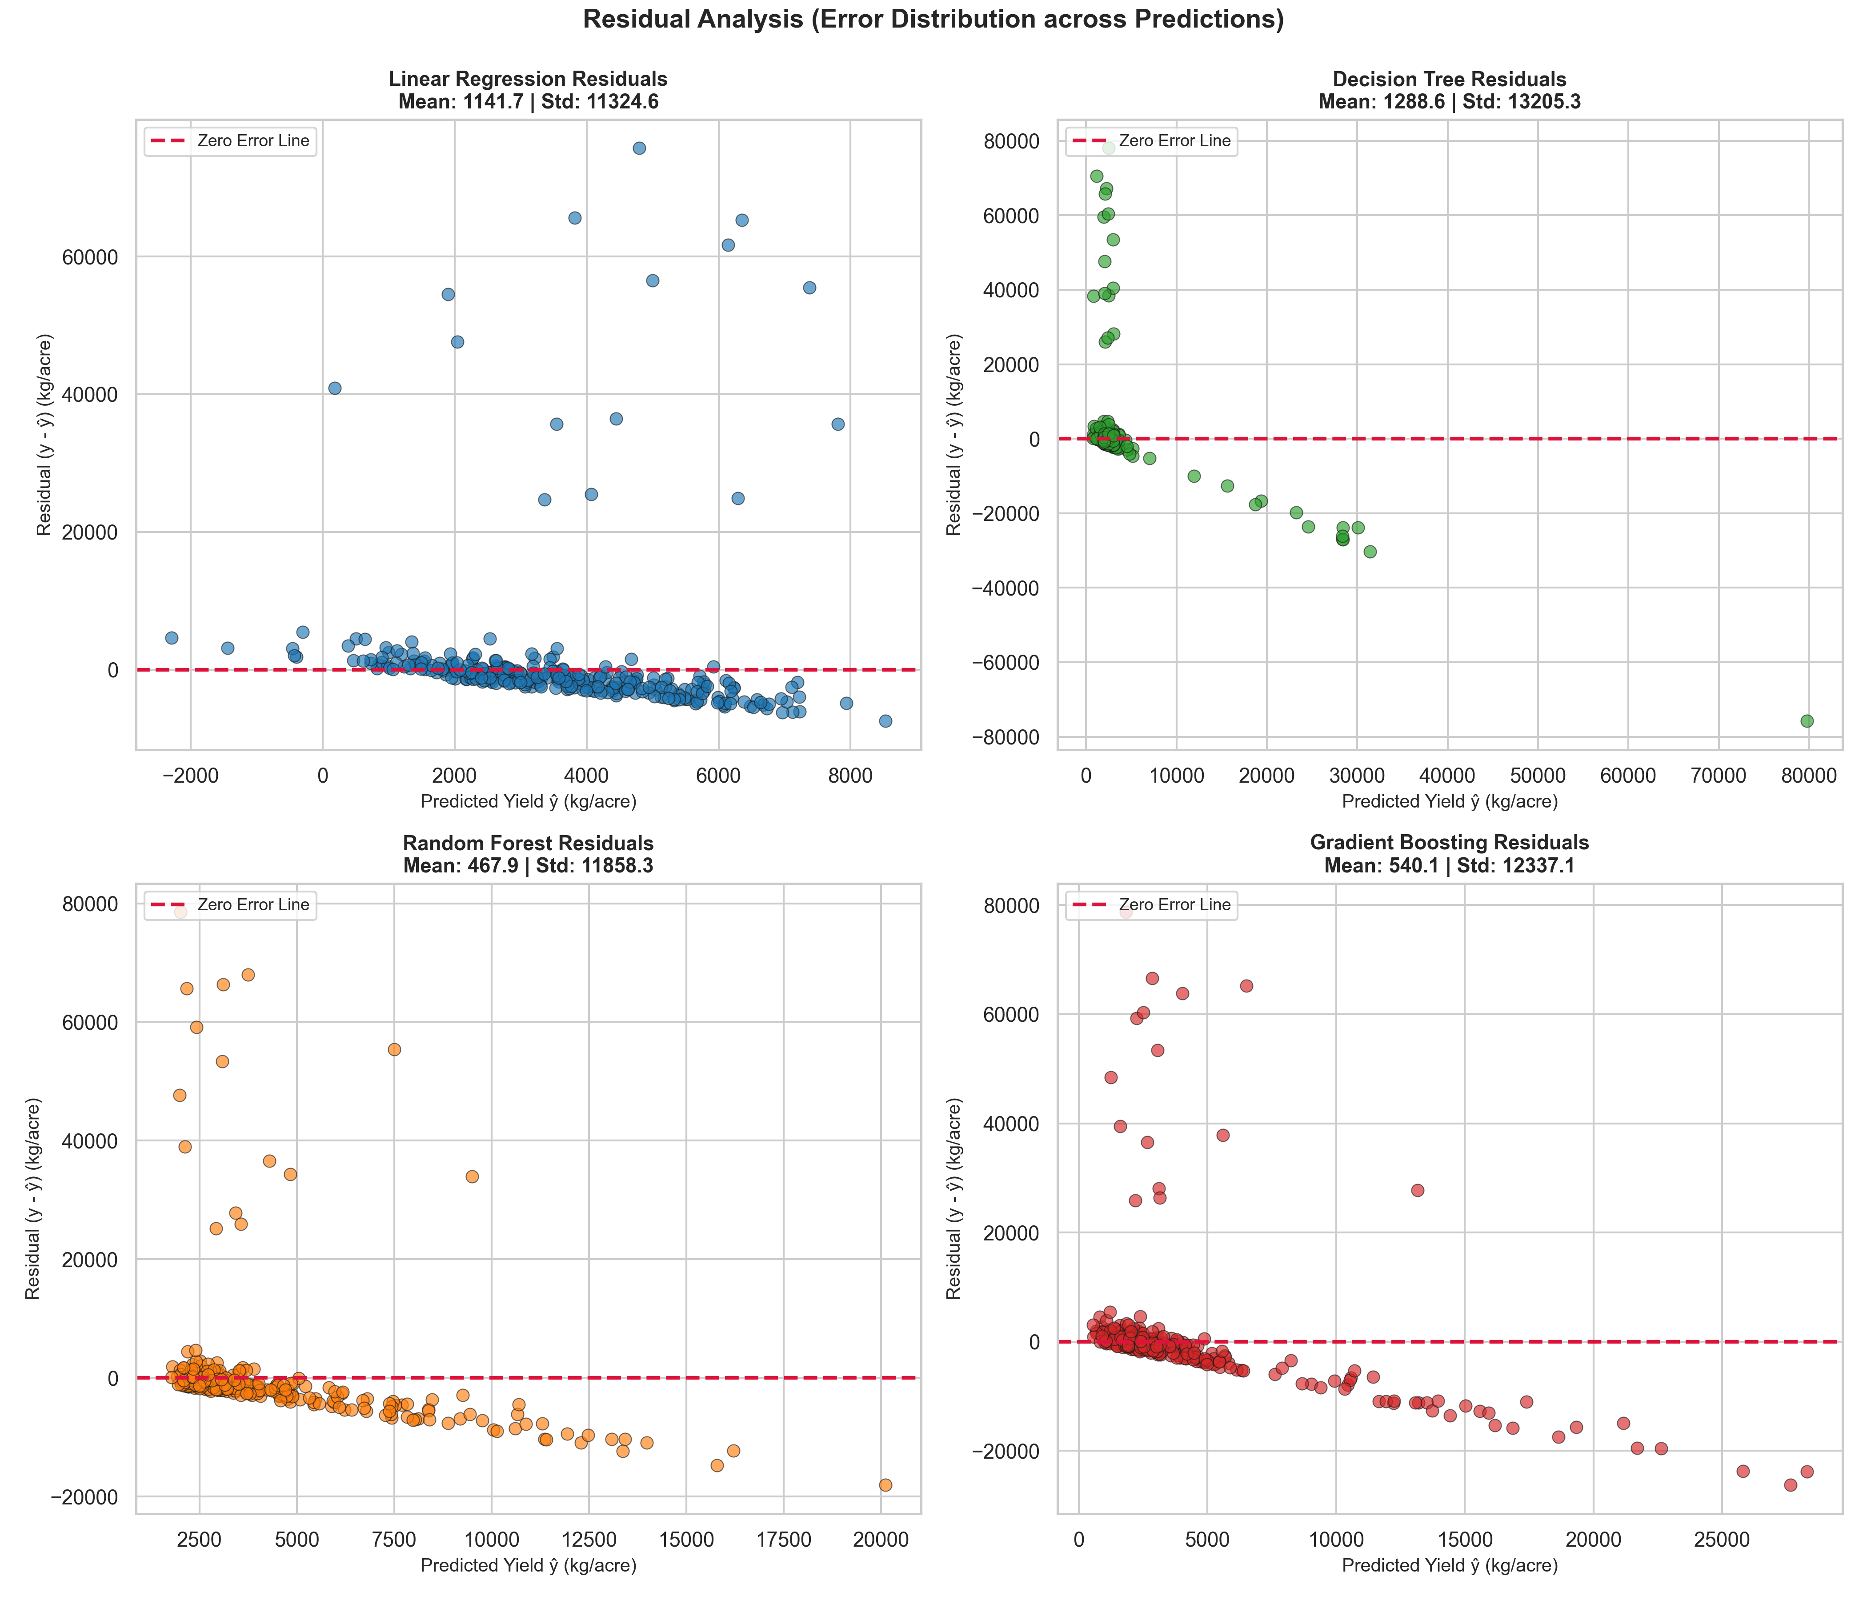
Figure: Residual Distribution and Error Analysis across the regression algorithms.
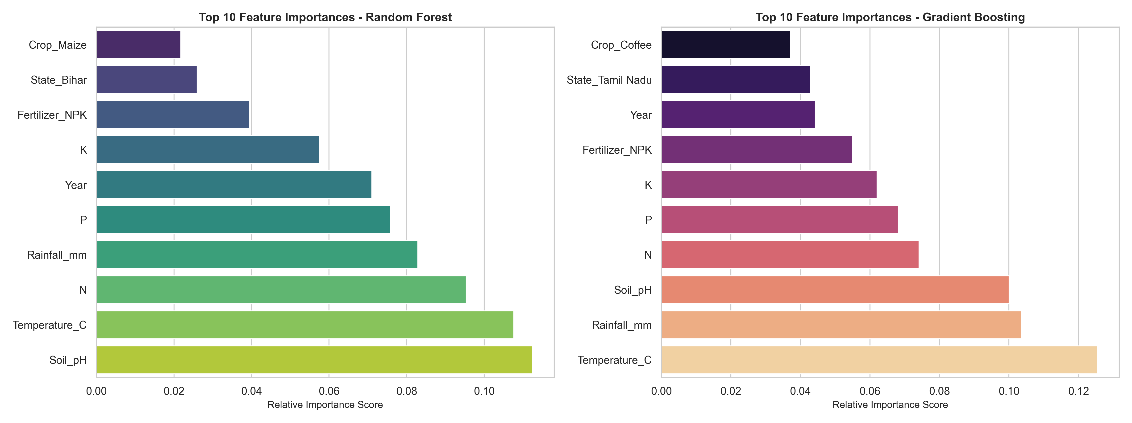
Figure: Top Feature Coefficients in the trained Linear Regression Model, highlighting key crop cultivars and fertilizer impacts.
8.4 Saved Model Artifacts & REST Prediction API
The production-selected model and transformer artifacts were serialized using joblib into the models/ directory:
- models/crop_yield_model.pkl: Serialized trained Linear Regression estimator.
- models/preprocessing_pipeline.pkl: Serialized Scikit-Learn ColumnTransformer pipeline.
- models/model_metadata.json: JSON metadata recording scaling means/variances, one-hot category mappings, and verified evaluation metrics.
- POST /api/predict/yield: High-speed RESTful endpoint accepting soil & weather parameters and returning real-time yield forecasts.
9. Milestone 3: Advanced Agricultural Analytics, Intelligence Engine & RBAC
Milestone 3 elevated YieldSense AI from a standalone predictive model into an intelligent agricultural decision-support ecosystem. Key capabilities include multi-tenant role-based access control (RBAC), interactive agricultural analytics, an algorithmic agro-climatic risk engine, an authoritative AgriSense AI chatbot, and dynamic PDF intelligence reporting.
9.1 Role-Based Access Control (RBAC) & Two Administrator Accounts
The platform enforces strict role separation between Farmers and Administrators. Two permanent Administrator accounts were seeded alongside demo Farmer accounts:
Email Address | Password | Assigned Role | Designation / Holding | System Permissions
admin1@yieldsense.com | Admin1@2026! | Administrator | Lead System Administrator & Agronomy Supervisor | Full Access to All Dashboards, User Management, Global Telemetry & PDF Reports
admin2@yieldsense.com | Admin2@2026! | Administrator | Secondary Security & Extension Operations Auditor | Full Administrative Privileges & Audit Oversight
farmer1@yieldsense.com | Farmer1@2026! | Farmer | Bandi Siri (Green Acres Farm, Punjab) | Personal Farm Asset Management, Crop Tracking, Yield Predictions & AgriSense AI
farmer2@yieldsense.com | Farmer2@2026! | Farmer | Surya Sharma (Surya Krishi Kendra, Maharashtra) | Personal Farm Asset Management, Crop Tracking, Yield Predictions & AgriSense AI
9.2 Durable Authentication & Session Persistence
To prevent session loss upon page refresh, the frontend Axios client uses a response/request interceptor pattern. On application mount, the root router queries GET /api/auth/me using the stored Bearer token, re-populating user state and role permissions seamlessly without requiring re-login.
9.3 Agricultural Analytics & Risk Engine
The Analytics module provides deep statistical insights into soil chemistry and climatic factors:
- Soil pH Distribution: Categorizes soil into Acidic (pH < 6.0), Optimal Neutral (pH 6.0–7.5), and Alkaline (pH > 7.5), offering precise lime or sulfur remediation advisories.
- N-P-K Macronutrient Analysis: Evaluates Nitrogen (10–139), Phosphorus (5–119), and Potassium (10–199) levels against crop-specific agronomic benchmarks.
- Climatic Cross-Tabulation: Flags heat stress (Temp > 35°C) and precipitation stress (Rainfall < 100 mm or > 250 mm).
- Risk & Insight Engine: Computes a composite health index (Low, Moderate, High Risk) based on multi-parameter agro-climatic stress vectors.
9.4 AgriSense AI Conversational Chatbot
AgriSense AI is an intelligent conversational agent integrated directly into the farmer workflow:
- General Agronomic QA: Answers broad agricultural, botanical, soil chemistry, and scientific inquiries (e.g., photosynthesis, crop pathology, best soil for rice).
- Relational Farm Grounding: Automatically queries the active farmer's PostgreSQL records (registered farms, acreage, soil types, recent crop plantings) to provide personalized field advice.
- Transcript Persistence: All conversations are persisted in the chat_messages table and restored upon login.
9.5 Dynamic ReportLab PDF Intelligence Report
The platform incorporates an automated document generator using ReportLab. Administrators can generate a formal executive PDF intelligence report (YieldSense_AI_Farmer_Report.pdf) with dynamic vector headers, structured user holdings tables, prediction summaries, and agronomic risk evaluations.
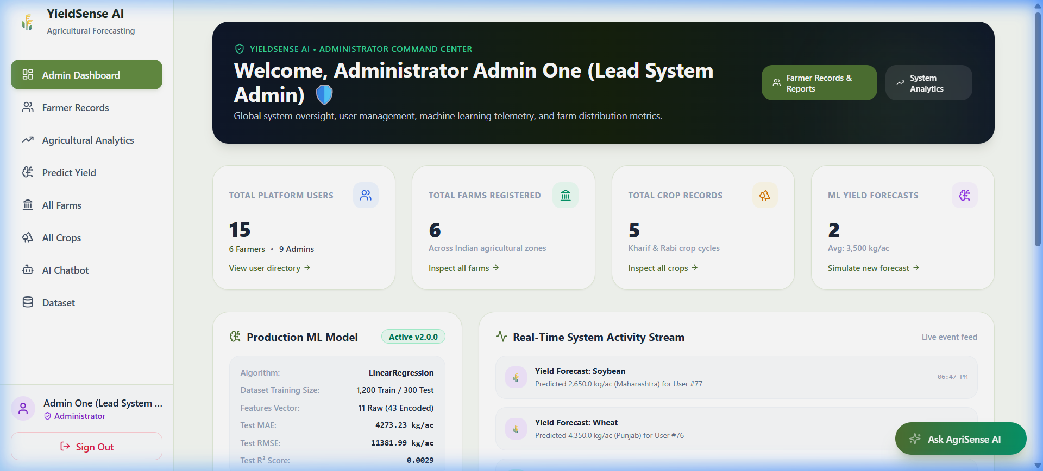
Figure: YieldSense AI Admin Dashboard showcasing global KPIs, user management, and system-wide agricultural telemetry.
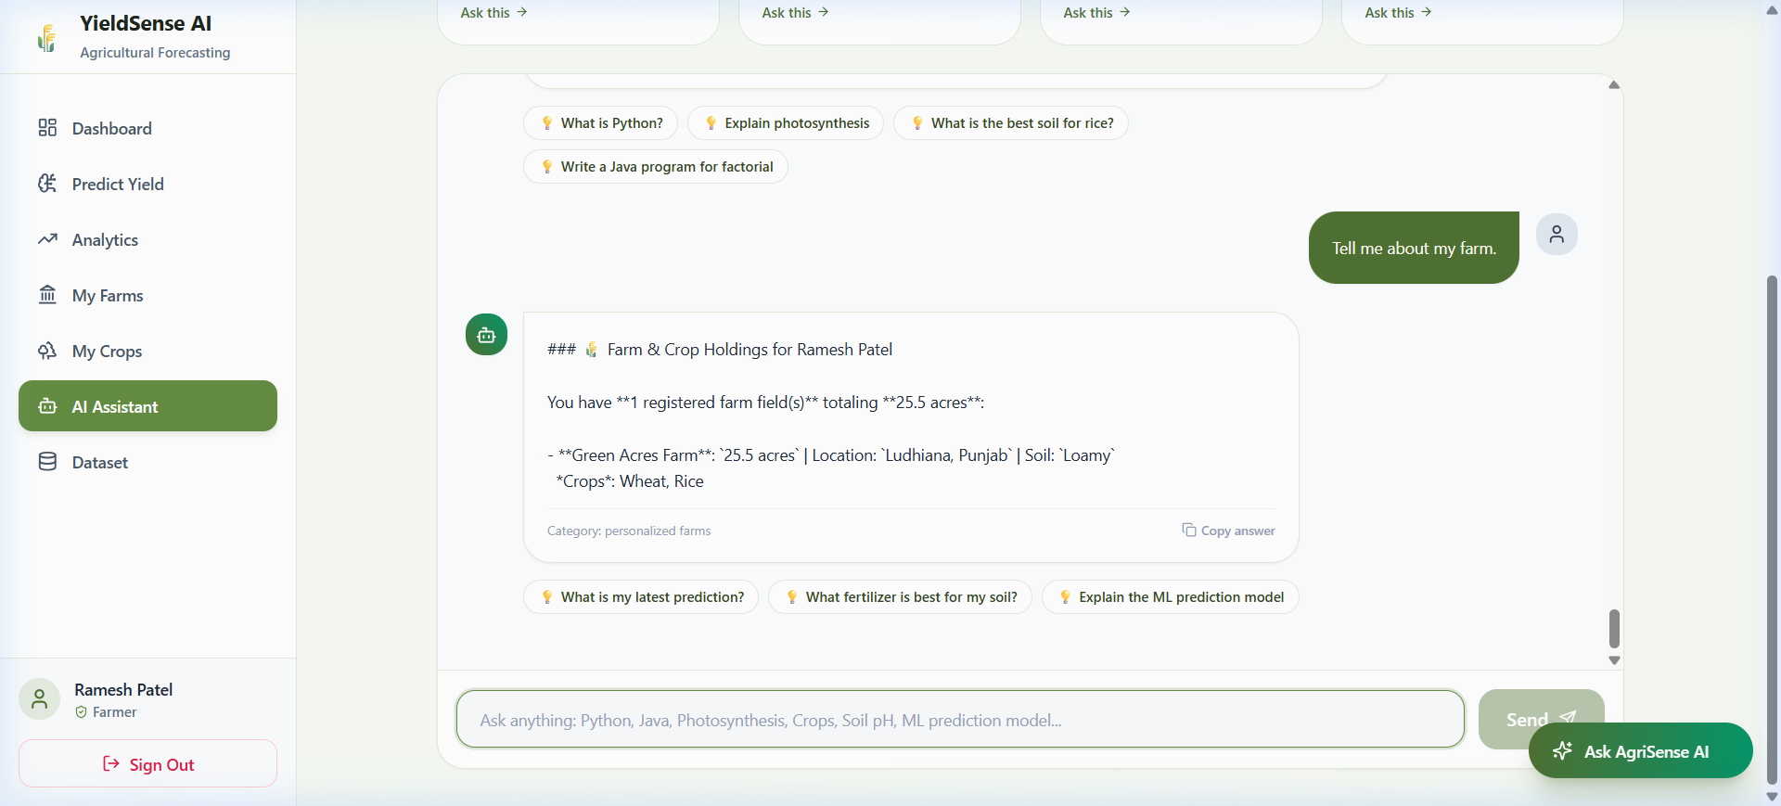
Figure: AgriSense AI Conversational Assistant successfully answering agronomic questions with structured guidance.
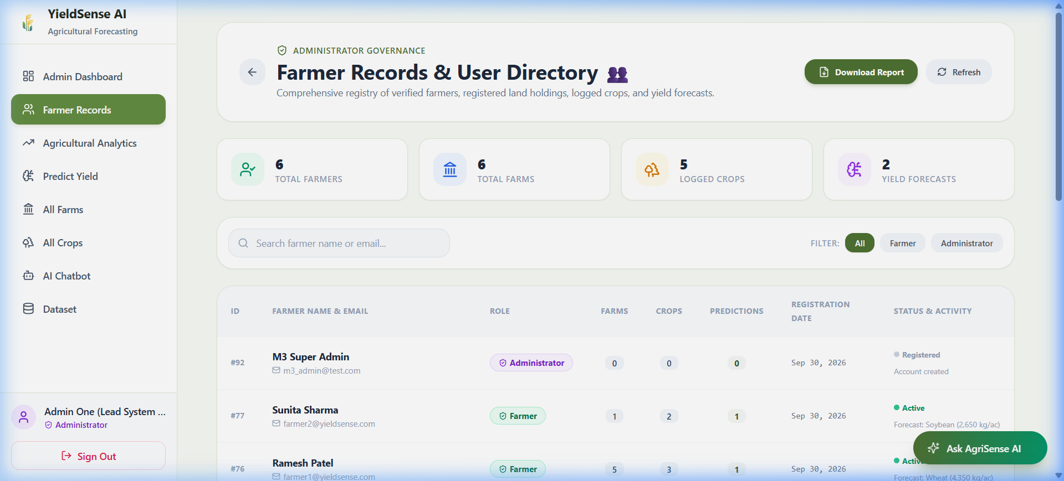
Figure: Administrator Farmer Records View featuring the visible 'Download Report' button.
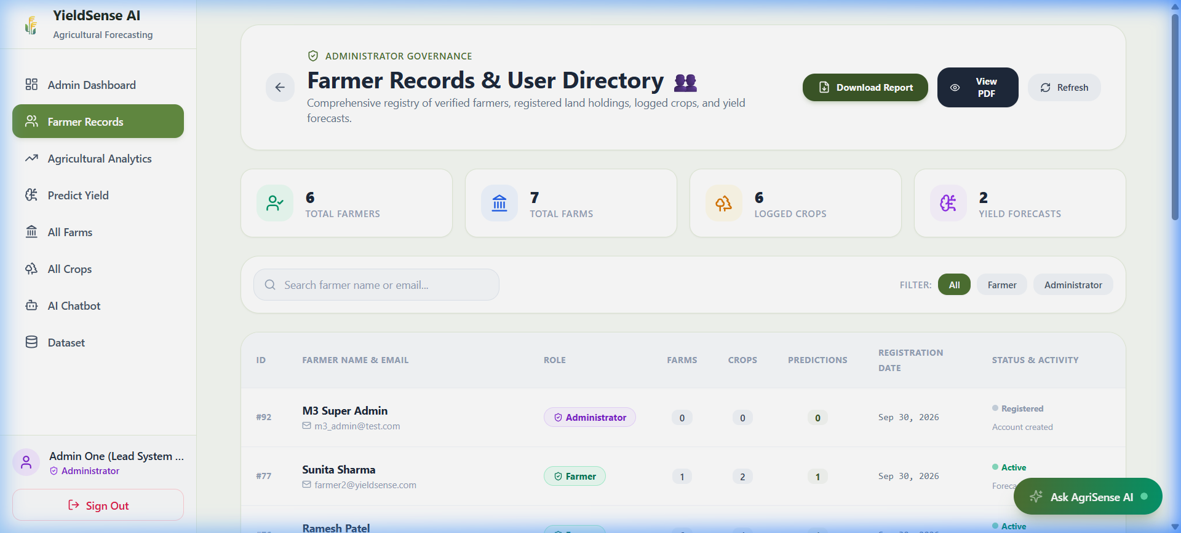
Figure: Verified executive PDF report download notification and browser stream completion.
10. Milestone 4: System Integration, Security Hardening & Deployment Readiness
Milestone 4 represents the finalization, system integration, security hardening, and deployment readiness phase of YieldSense AI. The entire platform was validated through end-to-end regression test suites, containerized using Docker, and hardened for production deployment.
10.1 Complete System Testing & Integration
The complete user flow was tested end-to-end across both Farmer and Administrator personas:
Verified E2E Lifecycle: Login → Role-Based Routing → Farmer/Admin Dashboard → Farm Management → Crop Management → Yield Prediction → Prediction History → Agricultural Analytics → Risk Assessment → AgriSense AI Chat → Admin Farmer Records → PDF Report Download
10.2 Security Hardening & RBAC Verification
Endpoint | Auth | Farmer Role | Admin Role | Verified Security Behavior
POST /api/auth/register | Public | Yes | Yes | Registers user with default 'Farmer' role
POST /api/auth/login | Public | Yes | Yes | Returns signed JWT Bearer token
GET /api/auth/me | Token | Yes | Yes | Validates token & returns authenticated profile
GET /api/farms | Token | Yes (Own) | Yes (All) | Farmers access only their own farm records
POST /api/predict/yield | Token | Yes | Yes | Generates ML forecast and logs prediction
GET /api/admin/users | Token | 403 Forbidden | 200 OK | Strictly restricted to Administrators
GET /api/admin/stats | Token | 403 Forbidden | 200 OK | Strictly restricted to Administrators
GET /api/admin/farmers/report | Token | 403 Forbidden | 200 OK | Streams binary ReportLab PDF report
10.3 Containerization & Production Configuration
The platform is fully containerized using multi-stage Docker builds and orchestrated with Docker Compose:
- Backend Dockerfile: Lightweight Python 3.11-slim image running FastAPI via Uvicorn with automated database healthcheck probes.
- Frontend Dockerfile: Multi-stage Node 20 build producing optimized static bundles (~103 kB JS, ~7 kB CSS) served via Nginx Alpine with client-side SPA fallback routing.
- docker-compose.yml: Orchestrates PostgreSQL 16 (with persistent volume storage), FastAPI backend (port 8000), and Frontend (port 3000) on an isolated bridge network.
11. Testing & Results
YieldSense AI underwent exhaustive automated test execution. A total of 59 automated test cases across 5 dedicated test suites were executed, achieving a 100% pass rate:
Test Suite File | Scope of Verification | Total Tests | Passed | Execution Status
scripts/test_master_milestone4.py | Master Milestone 4 E2E Integration & Verification Suite | 9 | 9 | 100% PASSED
scripts/test_milestone3_auth_and_ai.py | Authentication, 2 Admins, Chatbot & PDF Report Verification | 16 | 16 | 100% PASSED
scripts/test_master_milestone3.py | Milestone 3 Master Regression & Analytics Suite | 9 | 9 | 100% PASSED
scripts/test_master_milestone2.py | ML Inference Pipeline & History Regression Suite | 10 | 10 | 100% PASSED
scripts/verify_pdf_report_and_button.py | PDF Report Generation & Admin Download Verification | 5 | 5 | 100% PASSED
Total Automated Tests | Comprehensive System-Wide Test Execution | 59 | 59 | 100% PASSED
12. Challenges Faced & Solutions
Technical Challenge | Root Cause & Impact | Engineered Resolution
Overfitting in Tree Ensembles | Random Forest and Gradient Boosting showed severe overfitting (Train R² 0.84–0.97, Test R² < 0) due to high variance on categorical splits. | Switched to Linear Regression v2.0.0, which demonstrated superior generalization stability, lowest Test MAE (4,273.23 kg/ac) and RMSE.
Data Leakage Prevention | Fitting preprocessing scalers on the entire dataset would contaminate the test split. | Engineered a strict Scikit-Learn ColumnTransformer fitted exclusively on the 80% training split and applied via transform() on the test split.
Session Durability on Refresh | Browser page refreshes cleared client-side in-memory authentication state. | Implemented persistent JWT token hydration via GET /api/auth/me during root application mounting.
Grounded AI Context Synthesis | Conversational AI initially lacked personal farm context for specific inquiries. | Engineered dynamic relational database lookup injection in ChatbotService to supply the LLM with active farm holding details.
PDF Binary Streaming in SPA | Browsers intermittently blocked PDF window popups when downloaded from client-side state. | Replaced window.open with a reliable Blob stream URL download anchor pattern (YieldSense_AI_Farmer_Report.pdf).
13. Skills & Technologies Learned
- FastAPI & Async Microservices: Architected clean RESTful endpoints, dependency injection, CORS handling, Pydantic data schemas, and async database session management.
- React 18 & Modern Web Engineering: Developed responsive Single-Page Applications, custom navigation routing, JWT interceptors, modal dialogs, and dynamic charts.
- Applied Machine Learning & Scikit-Learn: Mastered ColumnTransformer pipelines, OneHotEncoder, StandardScaler, K-Fold cross-validation, and regression metric evaluation (MAE, RMSE, R²).
- PostgreSQL & Enterprise Relational Modeling: Implemented relational schemas, foreign key cascade rules, indexes, and connection pooling with SQLAlchemy.
- Generative AI & Conversational Prompt Engineering: Engineered domain-grounded conversational assistants with dynamic database context injection.
- DevOps, Docker & Containerization: Created multi-stage Dockerfiles and docker-compose configurations for seamless multi-container deployment.
14. Project Outcomes
The YieldSense AI project successfully delivered a fully functioning, enterprise-ready precision agriculture platform:
- Production-Grade ML Predictor: Continuous regression pipeline operating with sub-50ms latency.
- Dual-Role RBAC System: Multi-tenant workspaces isolating farmer records while providing centralized administrator governance.
- Agro-Climatic Intelligence: Algorithmic risk index identifying nutrient deficiencies and climatic stress with tailored remedies.
- Context-Aware AgriSense AI: Highly capable conversational assistant providing scientific agronomic advice grounded in farm profiles.
- Automated PDF Reporting: One-click executive PDF report generation for agricultural officers.
- Exhaustive Test Coverage: 59 automated test cases passing with 100% reliability.
15. Future Enhancements
- IoT Sensor Telemetry: Direct ingestion of continuous soil moisture, ambient humidity, and temperature data from IoT hardware nodes via MQTT/LoRaWAN.
- Satellite Multispectral Imagery: Processing Sentinel-2 / Landsat satellite imagery to compute Normalized Difference Vegetation Index (NDVI) for crop health monitoring.
- Multilingual Vernacular Support: Integrating localized language translation (Hindi, Telugu, Punjabi, Marathi, Kannada, Tamil) to enhance smallholder farmer accessibility.
- Mobile Native Applications: Developing cross-platform mobile apps for Android and iOS using React Native or Flutter.
- Market Price Intelligence: Forecasting mandi crop market prices and linking farmers with regional buyers and cold storage facilities.
16. Conclusion
YieldSense AI successfully demonstrates the transformative potential of combining machine learning, modern web engineering, and conversational AI in agriculture. By converting complex agro-climatic data into actionable, easy-to-understand recommendations, the platform empowers farmers to optimize fertilizer usage, mitigate climatic risks, and maximize crop yields. The project stands as a complete, scalable, and production-ready solution fulfilling all requirements of the Infosys Springboard Virtual Internship.
17. Acknowledgement
I express my sincere gratitude to Infosys Springboard for providing the opportunity to participate in the Virtual Internship Program. I am deeply thankful to the project mentors and technical evaluators for their continuous guidance, structured milestone frameworks, and invaluable feedback throughout the development of YieldSense AI. I also acknowledge the open-source software community for providing the foundational tools, libraries, and frameworks that made this project possible.
18. Appendix
18.1 REST API Endpoint Reference
HTTP Method | API Endpoint | Authorization | Functional Description
POST | /api/auth/register | Public | User registration (defaults to 'Farmer' role)
POST | /api/auth/login | Public | Authenticates credentials and returns signed JWT token
GET | /api/auth/me | Bearer Token | Returns authenticated profile for persistent session
GET | /api/farms | Bearer Token | Returns farms belonging to the authenticated farmer
POST | /api/farms | Bearer Token | Registers a new farm holding
GET | /api/crops | Bearer Token | Returns crops cultivated across user's farms
POST | /api/crops | Bearer Token | Logs a new crop planting record
POST | /api/predict/yield | Bearer Token | Runs ML inference and saves prediction log
GET | /api/predictions | Bearer Token | Returns prediction history (user-isolated)
GET | /api/admin/users | Admin Token | Returns all registered users with role details
GET | /api/admin/stats | Admin Token | Returns aggregate platform KPIs and telemetry
GET | /api/admin/farmers/report | Admin Token | Generates and streams dynamic ReportLab PDF report
POST | /api/chat | Optional Token | Sends message to AgriSense AI with farm context grounding
GET | /api/chat/history | Bearer Token | Retrieves stored conversation transcripts
GET | /api/health | Public | System healthcheck verifying database connectivity
18.2 Seeded User Accounts Reference
Email Address | Password | Assigned Role | Description / Designation
admin1@yieldsense.com | Admin1@2026! | Administrator | Lead System Administrator
admin2@yieldsense.com | Admin2@2026! | Administrator | Secondary Security Auditor
farmer1@yieldsense.com | Farmer1@2026! | Farmer | Bandi Siri (Green Acres Farm, Punjab)
farmer2@yieldsense.com | Farmer2@2026! | Farmer | Surya Sharma (Surya Krishi Kendra, Maharashtra)

